Part A — Practice Programs (Hour 1)
Work these in your lab-NN/ folder before the project: do the first one or two in the lab; the
last (For Advanced Learners) is for home.

1. Vending machine (VendingMachine.java, main in this file)
(a) Define an enum Coin with constants ONE, TWO, FIVE, TEN.
(b) In main, set a snack price of 15 and a running total of 0; create a Scanner.
(c) Loop: read a coin name, use a switch expression to convert the Coin to its value
(ONE→1, TWO→2, FIVE→5, TEN→10), add it to the total, and print the total so
far.
(d) Stop the loop once the total reaches 15 or more.
(e) Print the change to return (total − 15).
Expected output: TEN then FIVE prints “Paid. Change: 0”; TEN then TEN prints
“Paid. Change: 5”.

import java.util.Scanner;
public class VendingMachine {
enum Coin {
ONE, TWO, FIVE, TEN
}
public static void main(String[] args) {

final int PRICE = 15;
int total = 0;

Scanner sc = new Scanner(System.in);
while (total < PRICE) {
System.out.print("Enter coin (ONE, TWO, FIVE, TEN): ");
String input = sc.next().toUpperCase();
Coin coin = Coin.valueOf(input);
int value = switch (coin) {
case ONE -> 1;
case TWO -> 2;
case FIVE -> 5;
case TEN -> 10;
};
total += value;
System.out.println("Total so far: " + total);
}
System.out.println("Paid. Change: " + (total - PRICE));
sc.close();
}
}
OUTPUT:
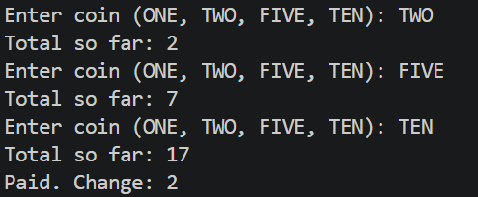

2. Toll booth (TollBooth.java, main in this file)
(a) Define a record Vehicle(String number, String type).
(b) In main, keep a running toll total and three counters (bike, car, truck).
(c) Loop until the user types “done” for the number: build a Vehicle, use a switch
expression on its type for the toll (bike→20, car→50, truck→150), add to the total,
and increment that type’s counter.
(d) After the loop, print the total toll and the type with the highest count.
Expected output: two cars + one bike → “Total toll: 120”, “Most frequent: car”.

import java.util.Scanner;
public class Tollb
{
public static void main(String[] args)
{
int car=50;
int bike=20;
int truck=150;
int total=0;
int b=0,t=0,c=0;

Scanner sc = new Scanner(System.in);
System.out.println("Enter number of vehicles and their type car , truck , bike : ");
int x = sc.nextInt();
for(int i=0;i<x;i++) {
String y = sc.next();
switch(y){
case "car":
total=total+car;
c++;
break;
case "truck":
total=total+truck;
t++;
break;
case "bike":
total=total+bike;
b++;
break;

}
}
System.out.println("Total "+b+" bikes "+t+" truck "+c+"car are there : ");
System.out.println("The total toll of all the vehicle is : "+total);
sc.close();
}
}
OUTPUT:
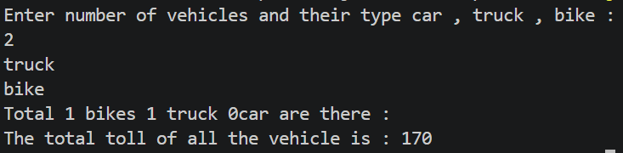
Key Questions / Analysis / Interpretation :
1. What is the role of the JVM, and what file does the javac compiler produce?
JVM (Java Virtual Machine) executes Java bytecode and makes Java platform-independent.
The javac compiler converts Java source code (.java) into bytecode stored in a .class file.

2. How does a switch expression differ from a traditional switch statement?
A traditional switch statement uses case, break, and often a default case to control execution.
A switch expression returns a value, uses -> for cases, and can be assigned directly to a variable.

3. Why is an enum a good choice for a fixed set of menu options, and a record for read-only data?
Enum: In my MiniBank program, MenuOption defines fixed menu options such as OPEN_ACCOUNT, DEPOSIT, WITHDRAW, TRANSFER, and EXIT. It prevents invalid menu choices from being represented as enum constants.
Record: A record is useful for storing read-only data because it automatically provides a constructor, accessor methods, and methods such as equals() and toString(). It reduces boilerplate code.

